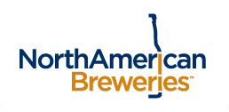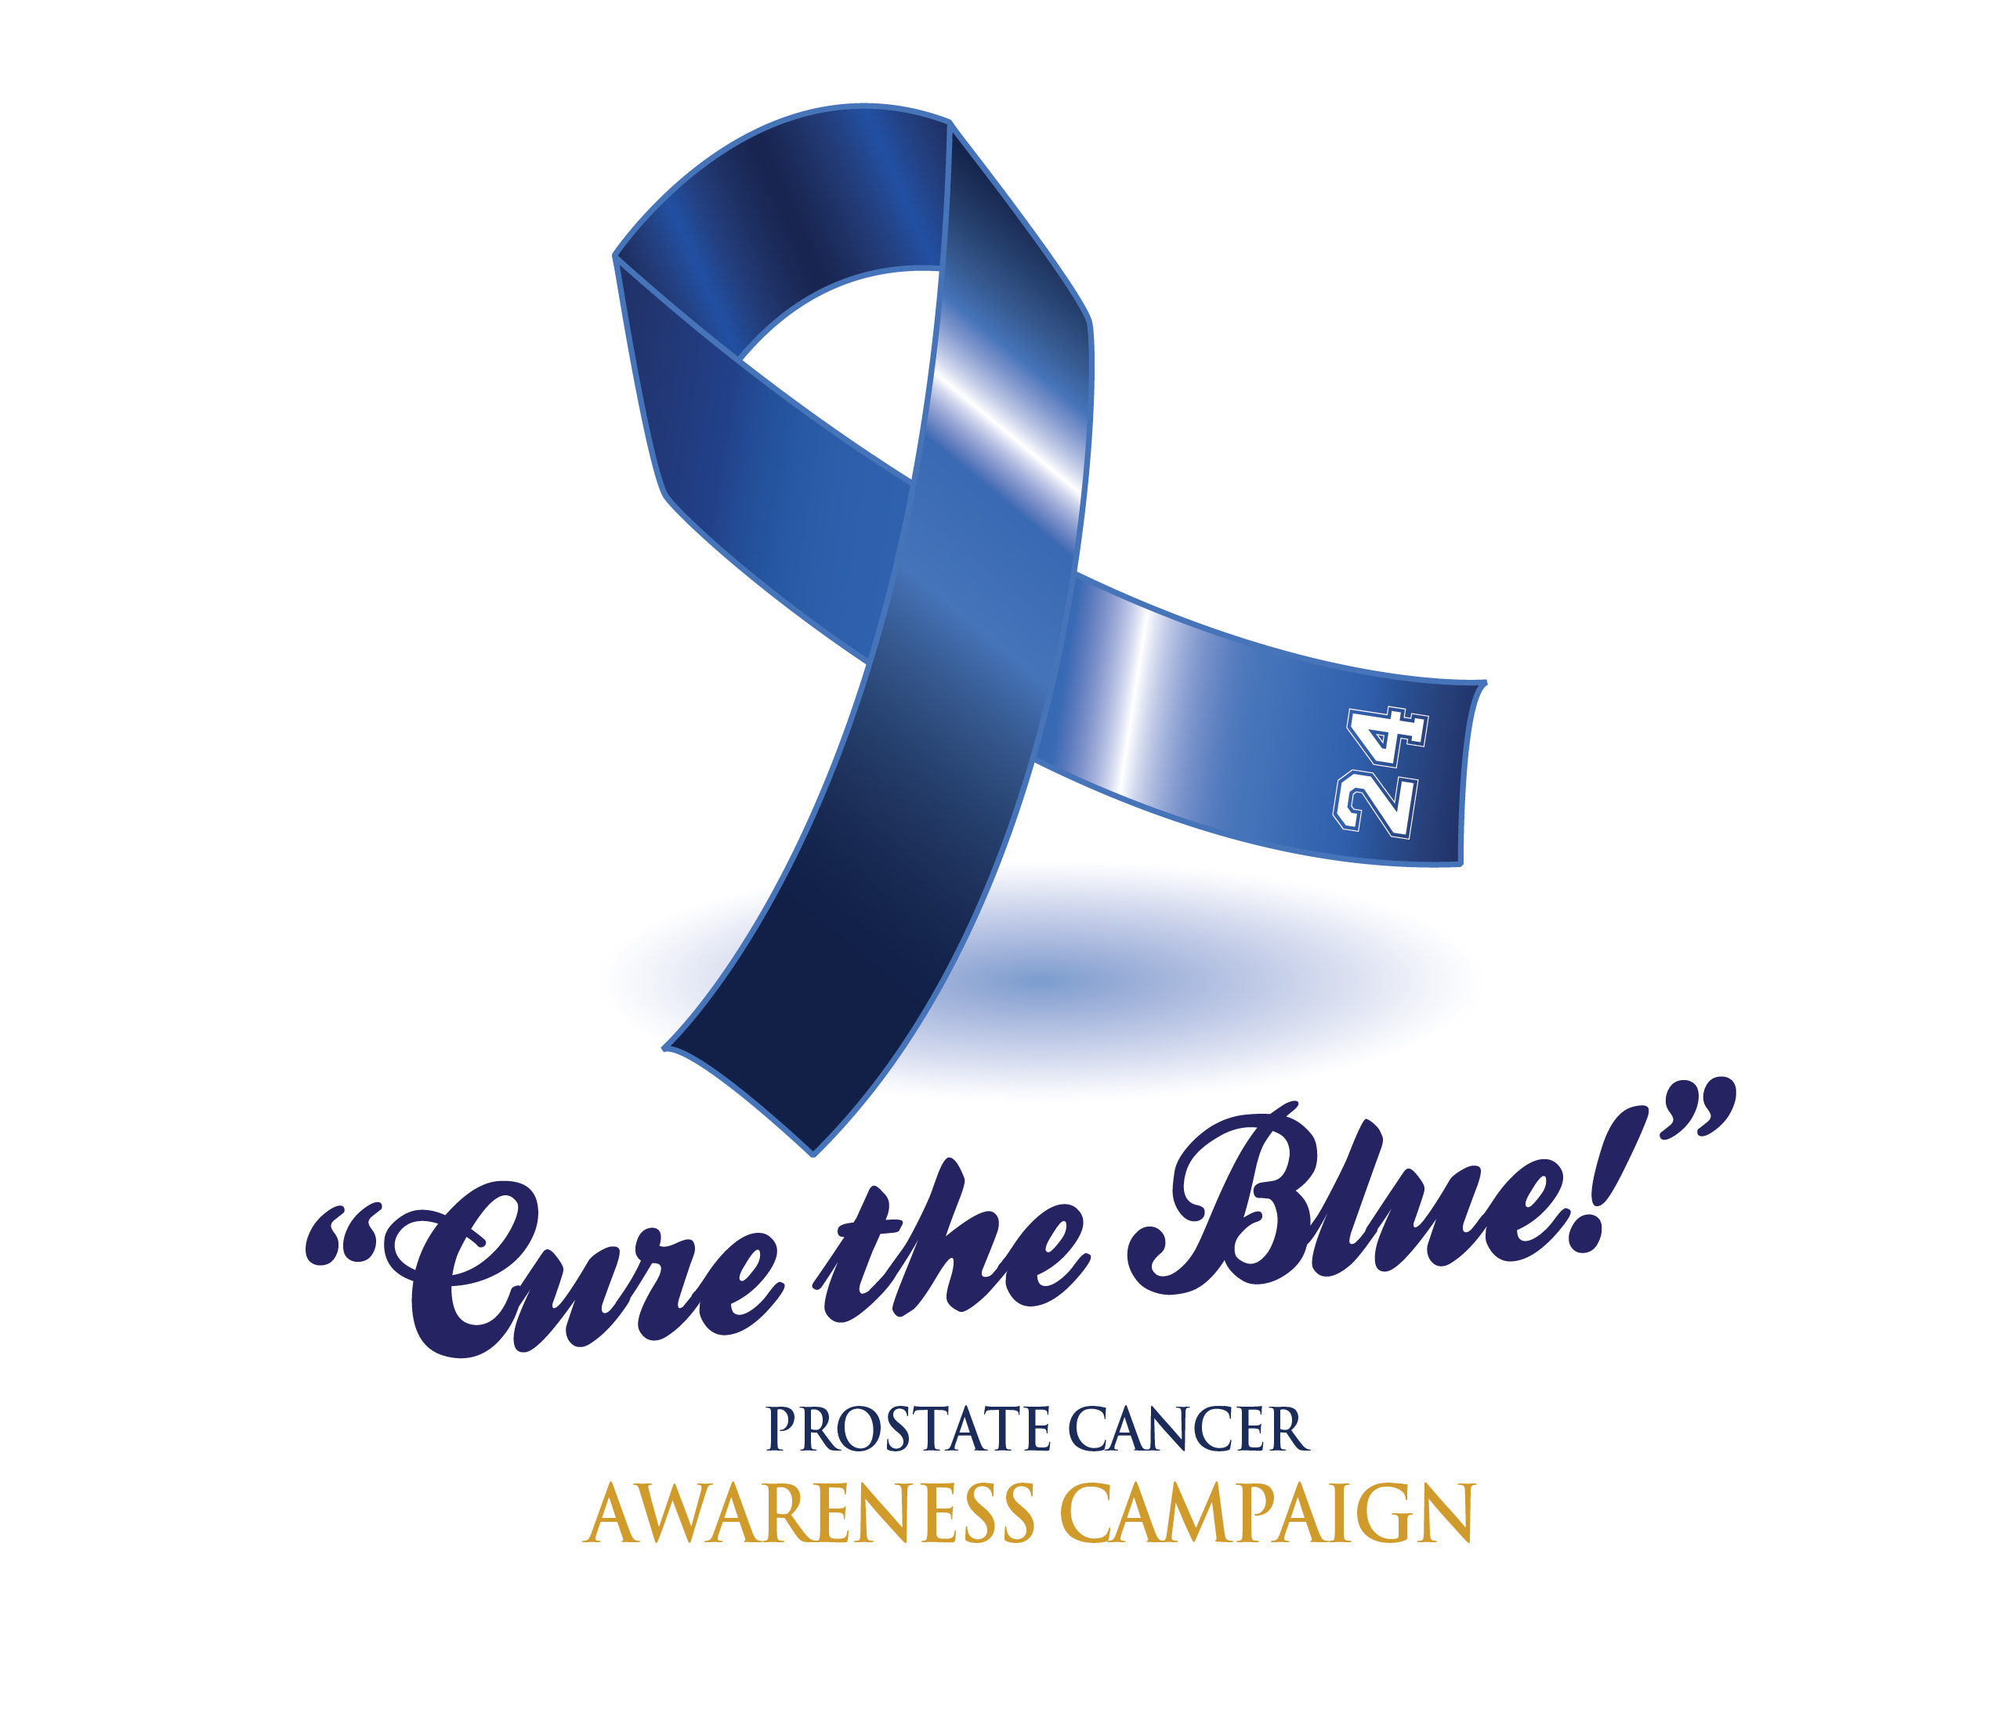
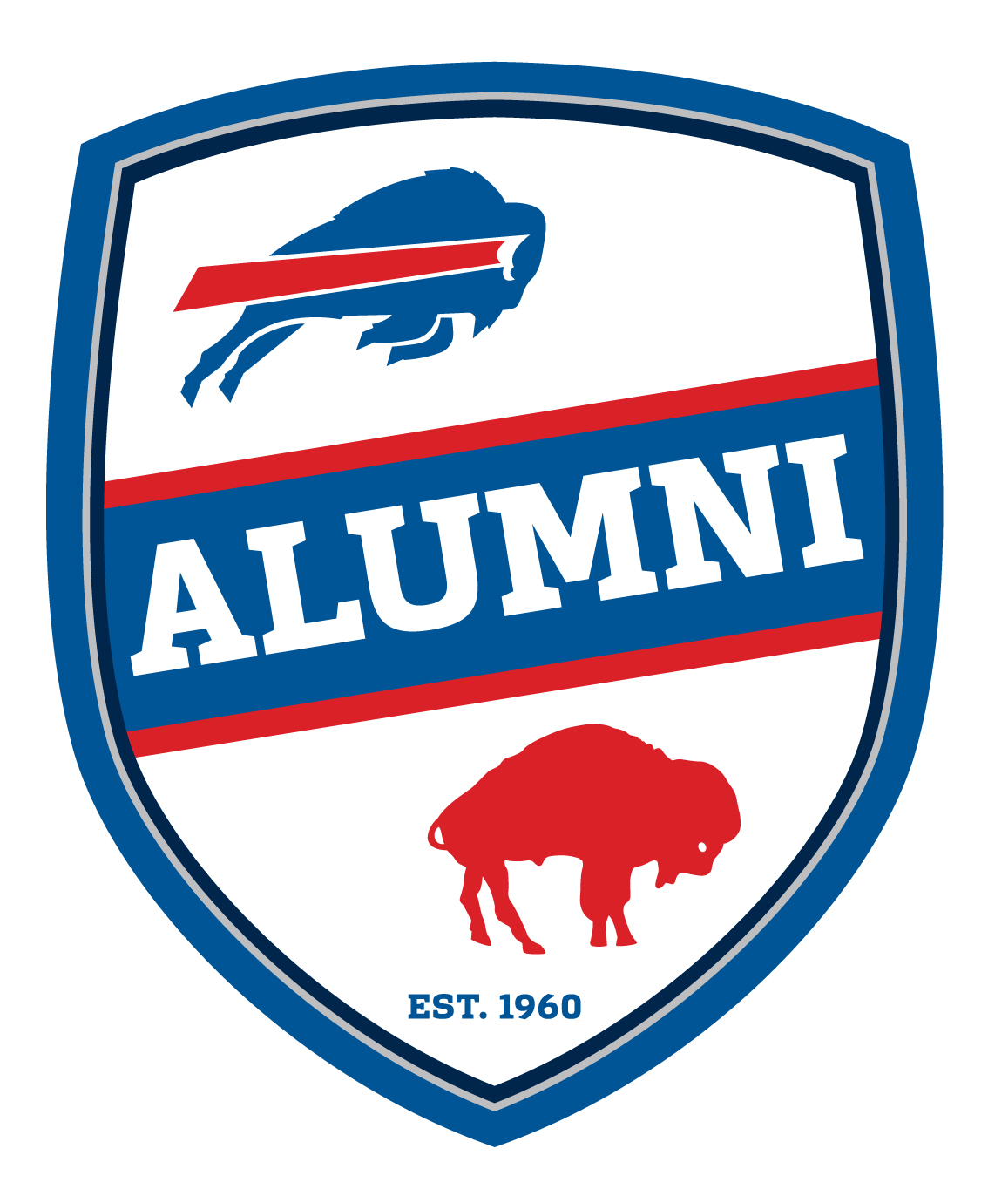

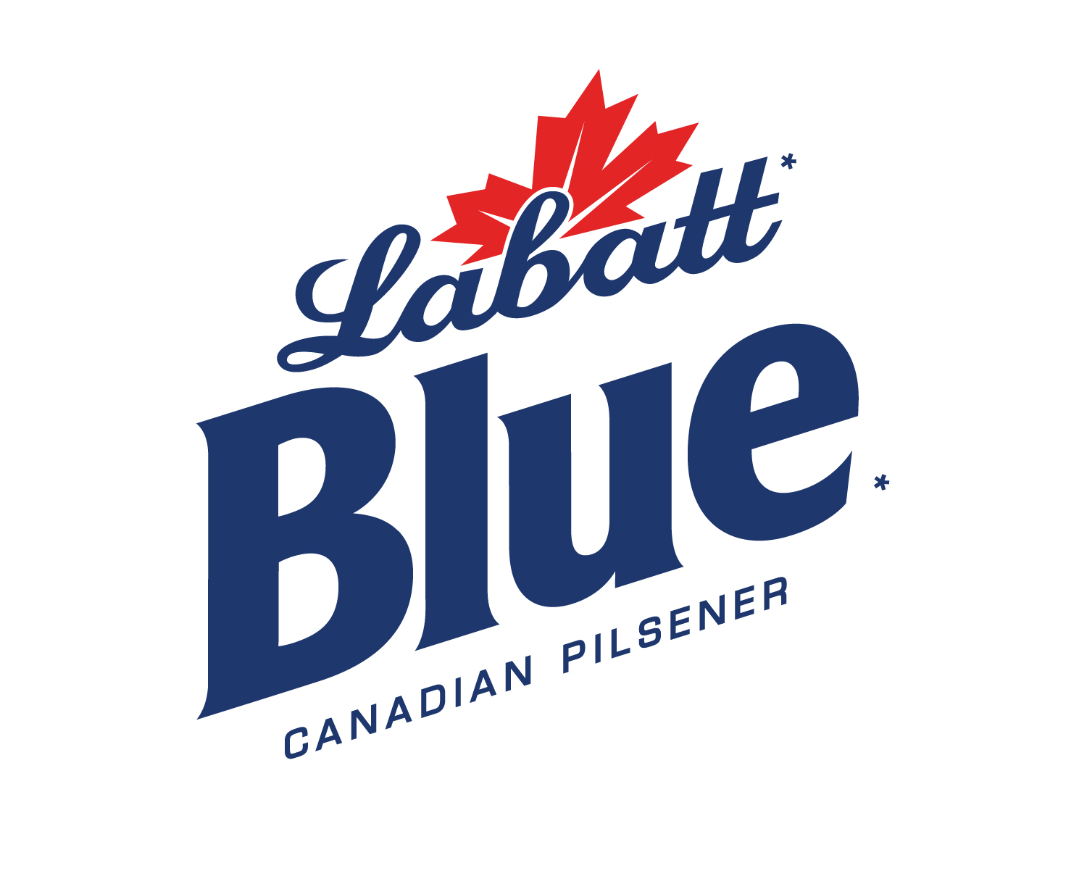
For Further Information Contact:
JRC Promotions, Joe Ciffa
716-694-7867 or 716-583-4710
or Booker Edgerson, Bills Alumni
716-631-0715 or 716-867-7837

FOR IMMEDIATE RELEASE:

Buffalo Bills Alumni Foundation, Labatt Blue and Walmart announce Partnership in the Prostate Cancer Awareness Campaign called “Cure the Blue”
Special Labatt Blue “Cure the Blue” Walmart stores throughout Upstate and Western New York will support the fight against prostate cancer. A portion of product sales will go toward the initiative.

September1, 2017…Buffalo, NY…The Buffalo Bills Alumni Foundation once again has taken the lead in the fight against Prostate Cancer through its “Cure the Blue” initiative and partnership with Labatt Blue and Walmart.

September is National Prostate Cancer Awareness Month. During the month of September, Labatt Blue will have special displays in several Walmart stores throughout New York State highlighting the Buffalo Bills Alumni Foundation’s Cure the Blue initiative to bring awareness, education and research to this devastating disease.

To support this effort, a portion of the sales specifically marked Labatt Blue and Blue Light 12 oz. 30-packs and 16 oz. 6-packs sold in September at participating Walmart locations in New York will help fund the Cure the Blue program.
( more)

continued from page 1

“ Labatt Blue is one of the top beer brands in our region. With their support, along with Walmart’s visibility and traffic, we will be able to share our message with thousands of people. We hope people will support this program to help bring much greater awareness to this dreaded disease” explained Buffalo Bills Alumni Wall of Famer and Foundation President, Booker Edgerson, a two time prostate cancer survivor.

“ The Buffalo Bills Alumni have been strong partners for years. By working together, we can encourage the general public and men in particular to get screened and tested for prostate cancer” said Izzy Rufat, Senior District Manager – Buffalo, North American Breweries.

Throughout the month of September, several Buffalo Bills Alumni will be signing autographs at designated Walmart locations in Western New York.

Here is the schedule of Walmart locations and times for the autograph signings;

1.) Walmart Clarence Store - Sept. 1st: 5033 Transit Rd. Williamsville, NY. Booker Edgerson, Ed Rutkowski, Paul Maguire. Time: 5pm--7pm

2.) Walmart Sheridan Dr./Bailey Ave. Store - Sept. 8th: 3290 Sheridan Dr. Amherst, NY. Lou Piccone, Marlo Perry, Will Fowler. Time: 5pm--7pm

3.) Walmart Lockport Store - Sept. 15th, 5735 S. Transit Rd. Lockport, NY. Booker Edgerson, Ken Jones. Time: 5pm--7pm

4.) Walmart Hamburg Store - Sept. 23rd, 5360 Southwestern BLVD. Hamburg, NY. Ed Rutkowski, Paul Maguire, Booker Edgerson. Time: 5pm--7pm

5.) Walmart Cheektowaga Store - Sept. 28th, 2500 Walden Ave Cheektowaga, NY, Booker Edgerson, Lou Piccone, Will Fowler. Time: 5pm--7pm

“Our support of the Buffalo Bills Alumni Foundation’s “Cure the Blue” initiative is something that we are taking very seriously” stated Walmart Market Manager, Michael Judd. “An effort of this magnitude to address the issue of prostate cancer is long overdue and we commend the Bills Alumni for taking the lead in this” added Judd.

“Cure-The-Blue” is a Major Healthcare Initiative sponsored by the Buffalo Bills Alumni Foundation that will allow anyone to participate in what is one of the greatest and most comprehensive efforts ever to help promote Prostate Cancer Awareness, Education, Prevention and Research in the United States.
( more )
continued from page 2

The Buffalo Bills Alumni Foundation was founded in 1999 and is comprised of past Bills players who have left an imprint on society during their football careers and want to continue molding society in a positive manner. Not only have they changed the game, but they have touched and shaped Buffalo as we know it today. The Bills Alumni Foundation has given over $2.2 million to local Western New York charities over the past 20 years.

- 30 -

